Making a Garden from Vegetable Scraps and Seeds

Earth Day, April 22nd is this week. Especially in these times, when we are asked to slow down and think of our footprint on the Earth, I thought it might be fun to explore (experiment) with making a garden from household scraps and seeds.

I figured this would be something for our budding scientists at home to explore and watch the daily changes. I’m hoping you have access to a little bit of earth and perhaps, some coffee grounds for fertilizer.

A few websites that could help you on this journey are:

https://earth911.com/home-garden/grow-food-from-scraps/

https://www.bing.com/videos/search?q=growing+plants+from+kitchen+scraps&&view=detail&mid=1EDD38BA4E1C4B7DF7D31EDD38BA4E1C4B7DF7D3&&FORM=VRDGAR&ru=%2Fvideos%2Fsearch%3Fq%3Dgrowing%2Bplants%2Bfrom%2Bkitchen%2Bscraps%26%26FORM%3DVDVVXX

https://www.apieceofrainbow.com/veggetables-herbs-regrow-kitchen-scraps/

I decided to used what I had in the house in the last few weeks. My experiments were with celery, onions, tomato seeds (taken out of tomato and dried for a few days first), and lettuce with a root ball.

Here is what my window garden looks like after about 1-3 weeks.

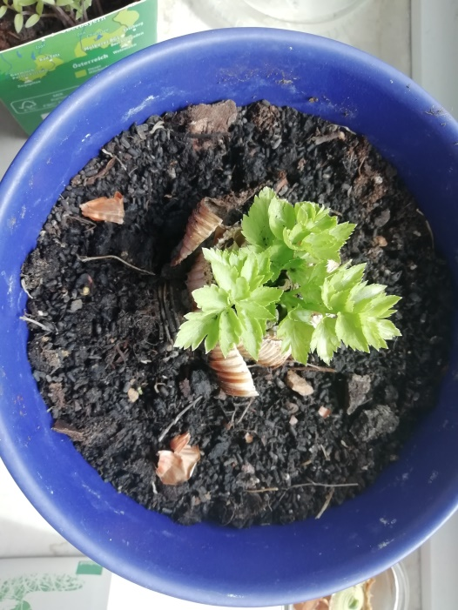 Celery Stalk after about 3 weeks

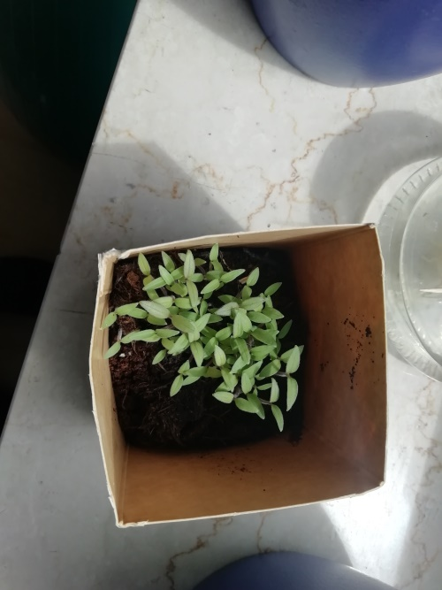 Tomato starts after 2 weeks

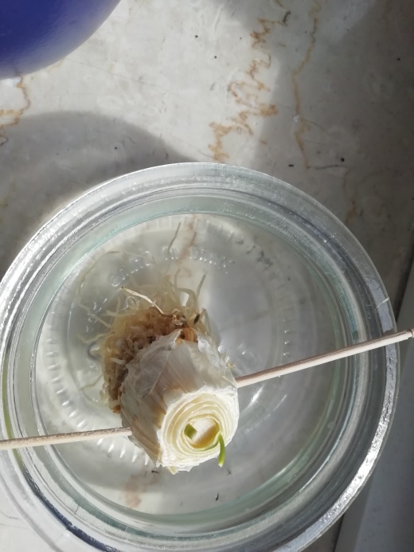 Leek root after about a week

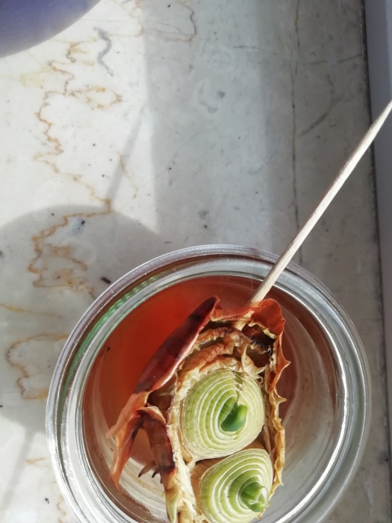 Onion base starting to regrow after a week

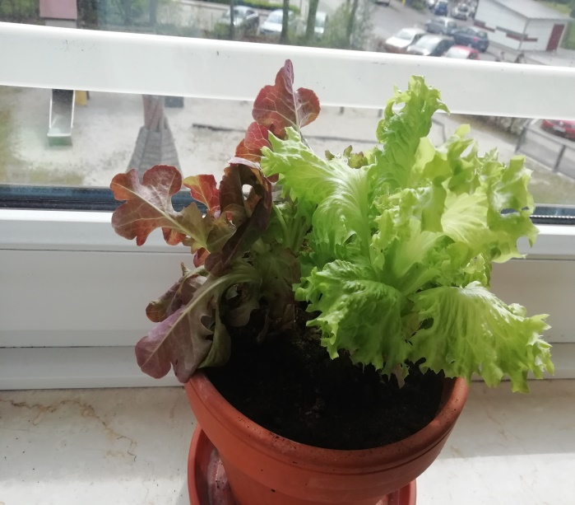 Salad with roots after 3 weeks (Salad bought

with root ball attached)

I’ve saved red pepper seeds and let them dry out but I haven’t planted them yet. I’ll try to do that soon and share a picture when I get the chance. Wishing you all some fun with budding green thumbs as we say in English. Here’s a nice chance to let the kids see if they can make something grow again and perhaps, the best part later will be to harvest it and eat it with the family. Enjoy!

