Earth Day Painting Project
from Nicole Woltron

I’m in the process of making things at home and thought I would share something you can do at home with your kindergarten and also school age kiddo(s).

Kids love to experiment with form and colors. We have seen in kindergarten how relaxed the kids come back from “Malort” with Brigitte. I like to take it one step further and let the kids paint with every day scraps we have around on the house. I’ve even taken dried flowers from a bouquet into the classroom and let the kids use them as paint brushes in small bundles. Just digging through your “Gelbesack” will probably yield a treasure trove of washable items to use as stamps or painting options.

I’m hoping you might have the following items at home to get started:

- acrylic paint ( textile paint will also work)
- brown or white packaging paper
- paint brush
- a glass
- other useful tools that can be washed or thrown away ( ex. fork, wine cork, kebab sticks, string, cut potato, sponge etc.)
- an old t-shirt or shirt from an adult that can get paint on it and can be used as a painter’s smock (kittel)
- paper towels to wipe brush or hands with
- table to work on (with a wax cover to wipe down easier )
- paper plates or plastic plates to put paint into

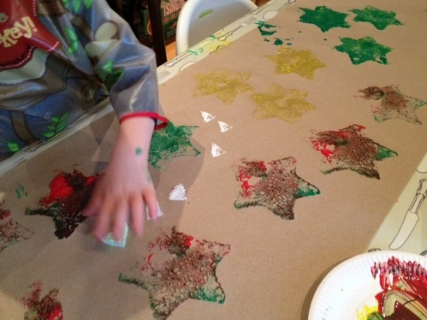
(photo from mykidcraft.com)

I usually improvise with what I use but this can keep a kid busy for good amount of time and focused on a task. I would recommend a parent be nearby so nothing else gets painted. Especially with the smaller ones! The older ones can be more responsible to keep paint contained.

Here’s some websites to check out what they did:
http://mykidcraft.com/homemade-sponge-stamping/
https://justbrightideas.com/homemade-wrapping-paper/
https://www.skiptomylou.org/reindeer-christmas-ideas/
https://artfulparent.com/homemade-wrapping-paper/

The Artfulparent.com website is one of my favorites. She always has interesting ideas for incorporating art into the everyday so feel to check out her website for more ideas to do at home.

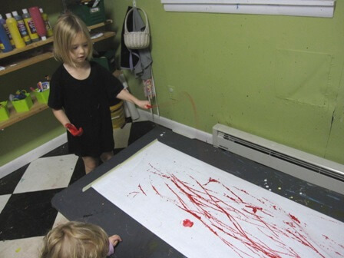
(photo from Artfulparent.com)

I think you can make fun wrapping paper year round but for some of you perhaps, this is a chance to get a heads up on Christmas wrap and you can add a personal touch for presents later in the year. Wishing you all some happy, creative moments!

